**Creating Microservices for account and loan**

**Account:  
AccountApplication.java:**

package com.cognizant.account;

import org.springframework.boot.SpringApplication;

import org.springframework.boot.autoconfigure.SpringBootApplication;

@SpringBootApplication

public class AccountApplication {

  public static void main(String[] args) {

    SpringApplication.run(AccountApplication.class, args);

  }

}

**AccountController.java:**

package com.cognizant.account;

import org.springframework.web.bind.annotation.GetMapping;

import org.springframework.web.bind.annotation.PathVariable;

import org.springframework.web.bind.annotation.RestController;

import java.util.HashMap;

import java.util.Map;

@RestController

public class AccountController {

    @GetMapping("/accounts/{number}")

    public Map<String, Object> getAccount(@PathVariable String number) {

        Map<String, Object> account = new HashMap<>();

        account.put("number", number);

        account.put("type", "savings");

        account.put("balance", 234343);

        return account;

    }

}

**Output:**

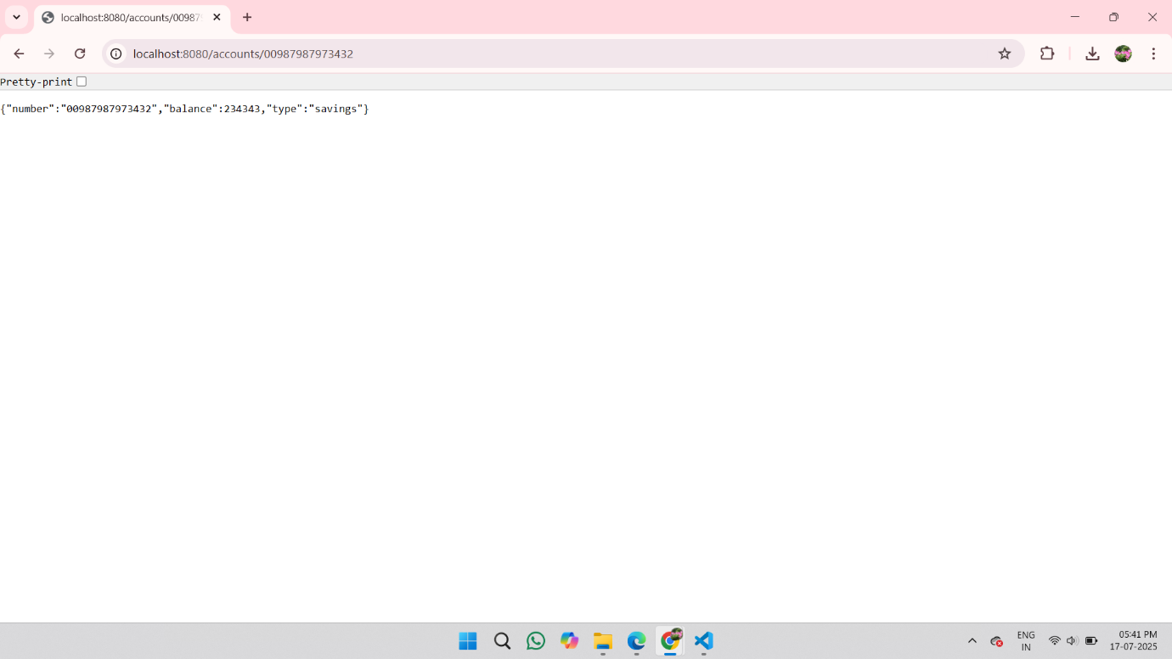

**Loan:**

**LoanApplication.java:**

package com.cognizant.loan;

import org.springframework.boot.SpringApplication;

import org.springframework.boot.autoconfigure.SpringBootApplication;

@SpringBootApplication

public class LoanApplication {

  public static void main(String[] args) {

    SpringApplication.run(LoanApplication.class, args);

  }

}

**LoanController.java:**

package com.cognizant.loan.controller;

import org.springframework.web.bind.annotation.GetMapping;

import org.springframework.web.bind.annotation.PathVariable;

import org.springframework.web.bind.annotation.RestController;

import java.util.Map;

@RestController

public class LoanController {

    @GetMapping("/loans/{number}")

    public Map<String, Object> getLoanDetails(@PathVariable String number) {

        return Map.of(

            "number", number,

            "type", "car",

            "loan", 400000,

            "emi", 3258,

            "tenure", 18

        );

    }

}

Output:

